Bootstrap Assignment

Introduction

This assignment will give you the opportunity to explore the Bootstrap Grid System by building a responsive photo grid that is common across the web.

OUTCOMES & LEARNING OBJECTIVES

* Understand and implement the Bootstrap Grid System to create responsive layouts
* Use Bootstrap's pre-defined classes to minimize the CSS you need to write

Instructions

Download starter file. Using Bootstrap, create a page that looks like the following:

### Large and Medium Screen Size

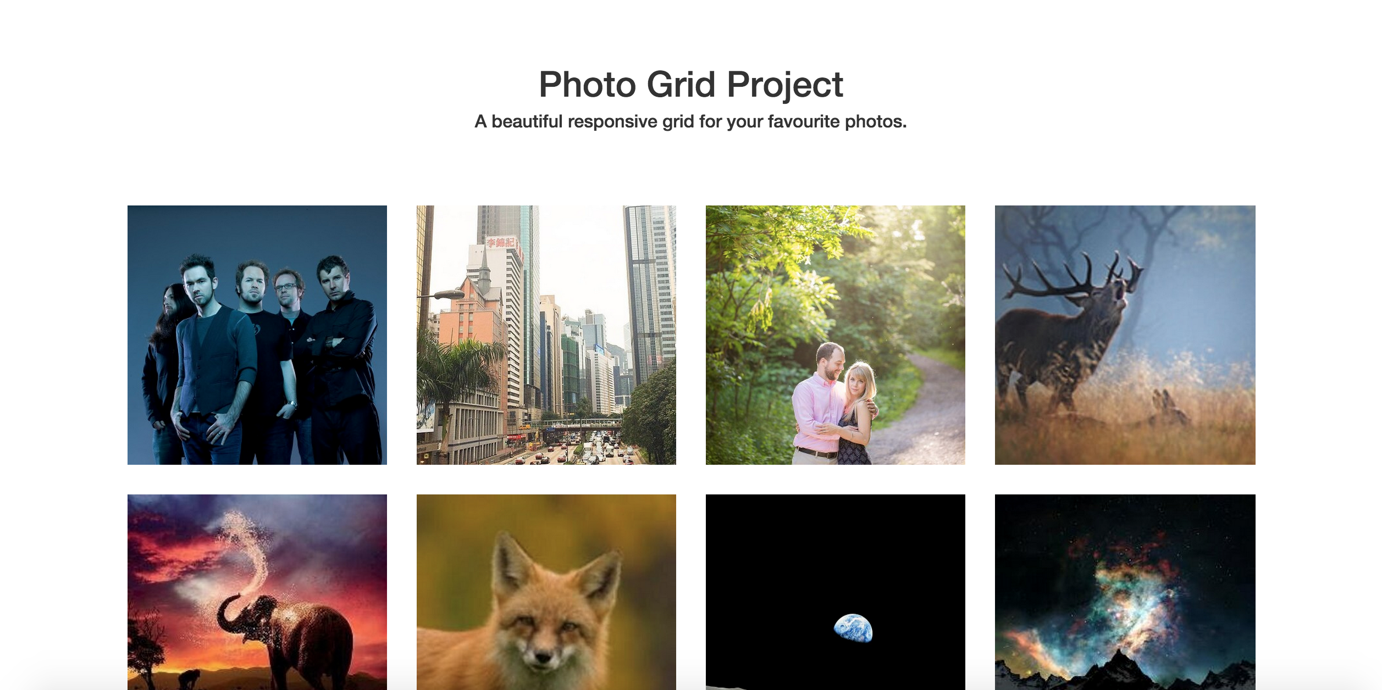

### Small Screen Size

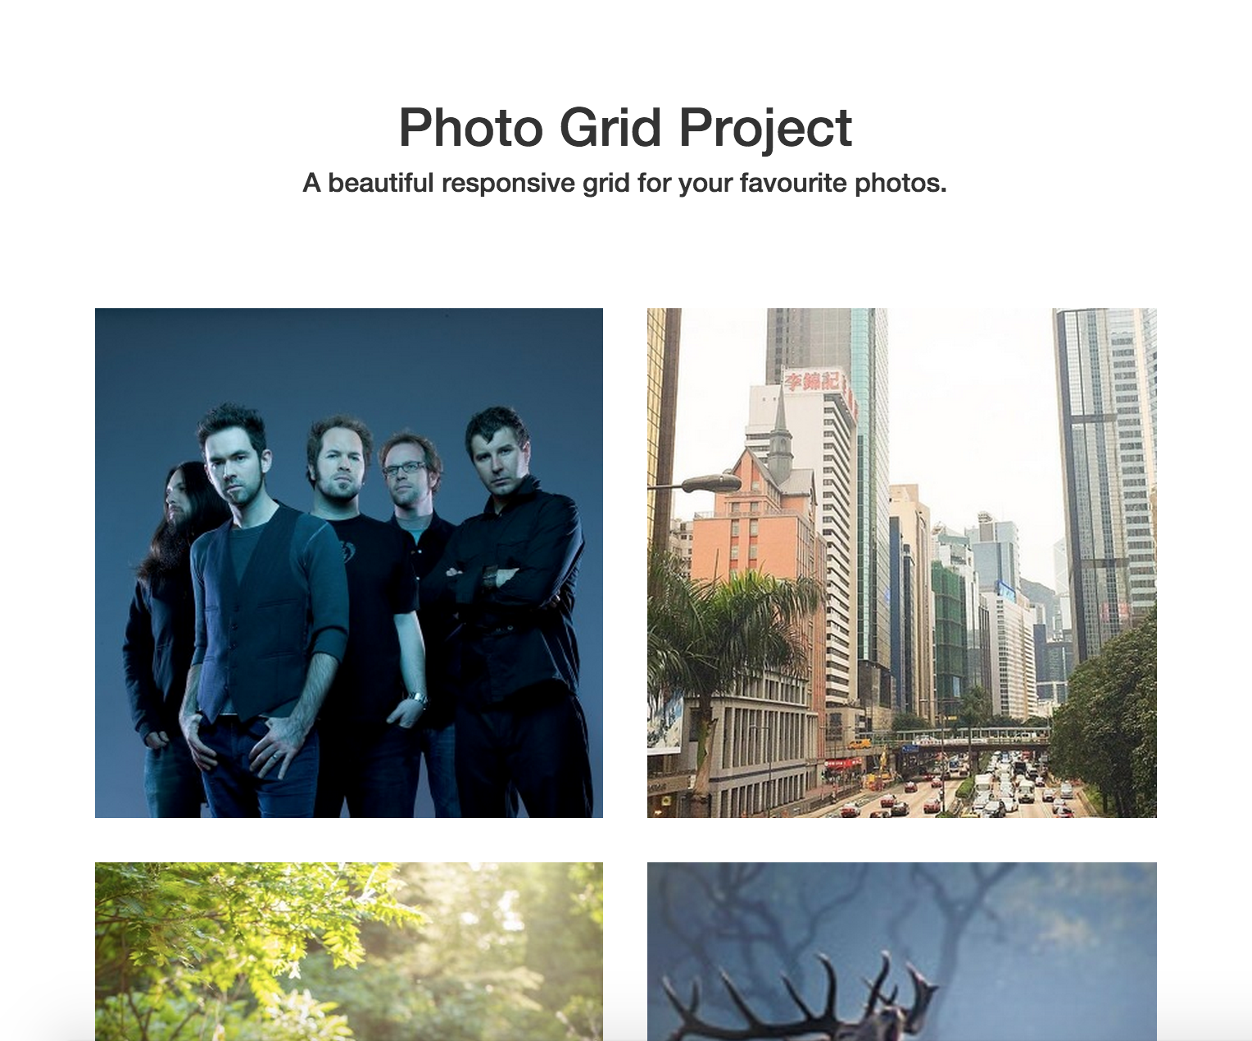

### Extra-Small Screen Size

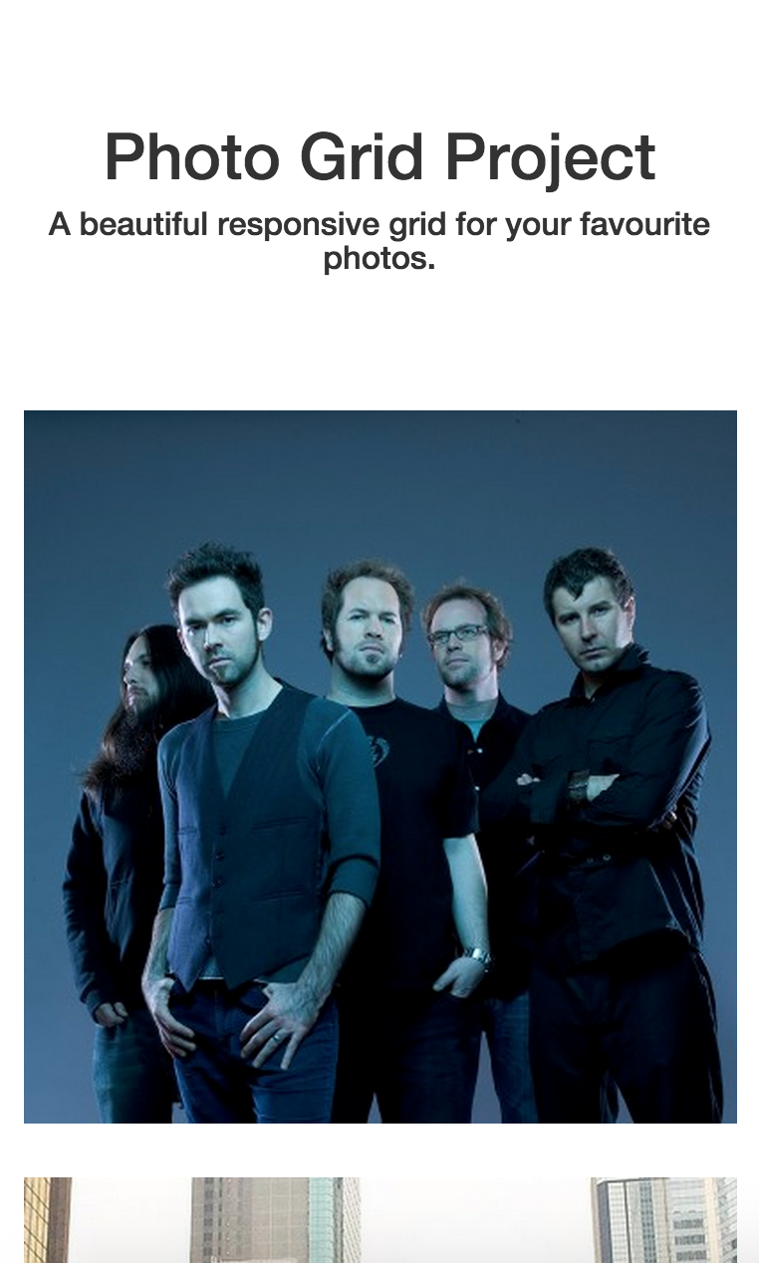

DIVINGDEEPER

Try adding a title and a "like" button to each photo. The title and "like" button should adjust nicely as the photo grid changes shape based on the size of the screen.

This challenge will be considered complete when the site is:

1. Structured with Bootstrap's Grid System
2. The webpage is responsive on all screen sizes
3. Resembles the pictures provided in the Instructions section

#### CRITICAL REFLECTION & SELF-ASSESSMENT

Consider some of these points when you have completed the challenge:

* Do you understand how to use Bootstrap's grid system across multiple screen sizes?
* Do you understand how to read Bootstrap's documentation to get the information you need to implement Bootstrap in your own projects?